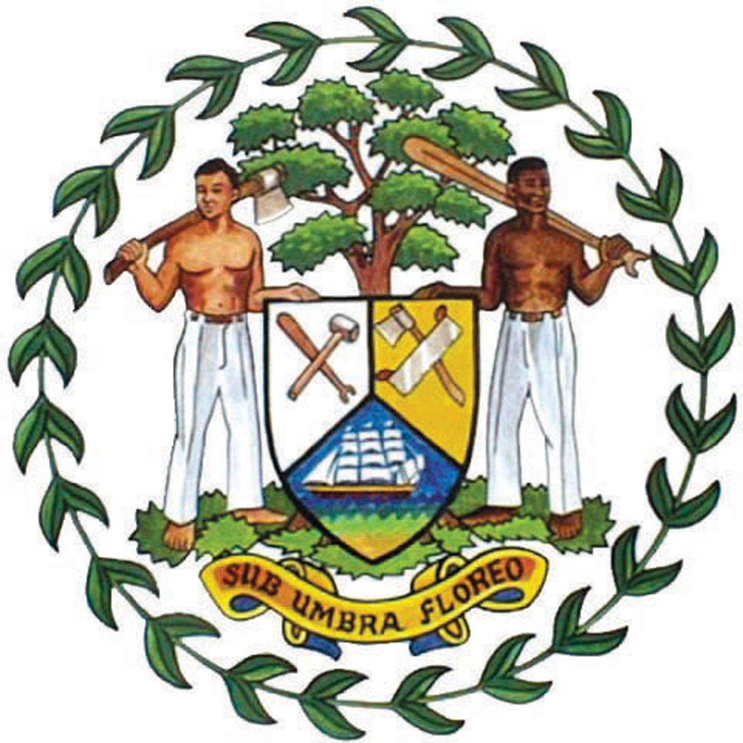

BELIZE PRESS OFFICE
●Phone: 822-0094 or 0092 ●Fax: 822-2671 ● website: www.belize.gov.bz

PRESS RELEASE

Ministry of Health Announces the Use of Antigen Rapid Testing for Specific Population Groups

Belmopan. October 30, 2020. 5:00 p.m.

The Ministry of Health hereby informs of its intention to start using antigen rapid testing for COVID-19 following established protocols.

After completing a validation exercise with the SD Biosensor Antigen testing kit and following international recommendations, use of this antigen testing kit will ONLY be applicable and is recommended for persons who are:
I) Symptomatic
II) Close contacts of a confirmed case

As established under the Public Health Regulations, all notifiable diseases including positive cases for COVID-19 must follow the established reporting mechanism for communicable/notifiable diseases and it must be done through the established reporting tool developed by the Ministry of Health.

At this time, the Ministry is unable to endorse or validate any other rapid testing kit for use in other categories of the population. If this position should change, it will be announced accordingly. The Ministry will not be held accountable for the outcome of the use of any other rapid testing kit.

The Ministry of Health continues its active surveillance efforts and expansion of its testing processes and procedures.

Ends

